**Brief story preamble**

Transport is important and has been explored from many different strands of literature all emphasising different things

It has changed over time

We want to shift towards more sustainable modes of transport

Therefore, it is worth exploring whether we can identify MSOA with a similar transport characteristic to subsequently inform ways in which policies could be targeted to certain areas to alter transport modes. (and understand what demographic factors are likely to influence this)

**The Average MSOA:**

Data from: all_transport_averages.csv – this contains information on all transport modes in MSOAs

Here we see the transport characteristics of the average MSOA. From this it can be seen that the average MSOA is dominated mostly by car travel with 60% of people travelling to work travelling by car. This is complemented by around 74% of households owning cars. This is followed by 10% of individuals who work from home and around 10% of people who travel to work on foot. The overall percentage of those who travel by public transport, including trains, busses and undergound/metro is around 15%.

In terms of stations, bus stops are by far the most common with the mean number of bus stops per MSOA of 38.5 for a total of 277,094 bus stations in the England and Wales. In terms of train stations, out of 7201 MSOAs in England and Wales only 1811 MSOAs have train stations, for a total of 2,305 train stations meaning an average MSOA has 0.32 train stations. This is even lower for metro, tram or underground stations as only 535 MSOAs have these stations for a total of 899 stations in England and Wales. This means that the average MSOA has only 0.128 stations.

Then we can explore travel times from each MSOA to reach all others and the travel times of those who do travel via that mode. It is clear from these that traveling by car has the most accessibility and for those that do travel by car on average travel for 12 minutes to their workplace. While bus may be the slowest for travelling to other MSOAs, those that do travel by bus to work spend an average of 28 minutes to work, followed by those travelling by rail to work who spend an average of 68 minutes.

**The range of differences in MSOAs:**

Data from: all_transport_averages.csv

The average MSOA seen above shows clearly that most people in the UK travel by car, however this varies significantly across the UK as can be seen in the following chart. The maximum percentage of people travelling by car in an MSOA is 84% while the minimum number of people travelling is 3%. The standard deviation for this is 16.5% showing that there is significant variation in car usage.

(Using the current information this could be made interactive etc. This could also be replaced with a historgram showing the distribution of car usage, the MSOAs with the minimum and maximum or other information, if you want the histogram then this will likely require an API or something, the MSOAs will show pictures etc)

This can also be seen in public transport usage across England and Wales. While the averages for England and Wales MSOA, although the mean for unground/tram/metro, train and bus usage is 3.4%, 4.7% and 7.3% respectively we can see that there is considerable variation and the MSOA who use these types of transport the most showing that up to 50% of people in an MSOA may use one of these methods of travel to travel to work.

(Again, this can be changed to show the MSOAs which have the max, the histogram showing the distributions or all three modes of transport combined)

Furthermore, looking at the distribution of bus stops, train stations and metro stations, it can be seen that there is variation about where they are located and their concentration across England and Wales. (of course these maps would be cleaned up and made to look prettier but it may be best to have them static as don’t want too much interactive of the map)

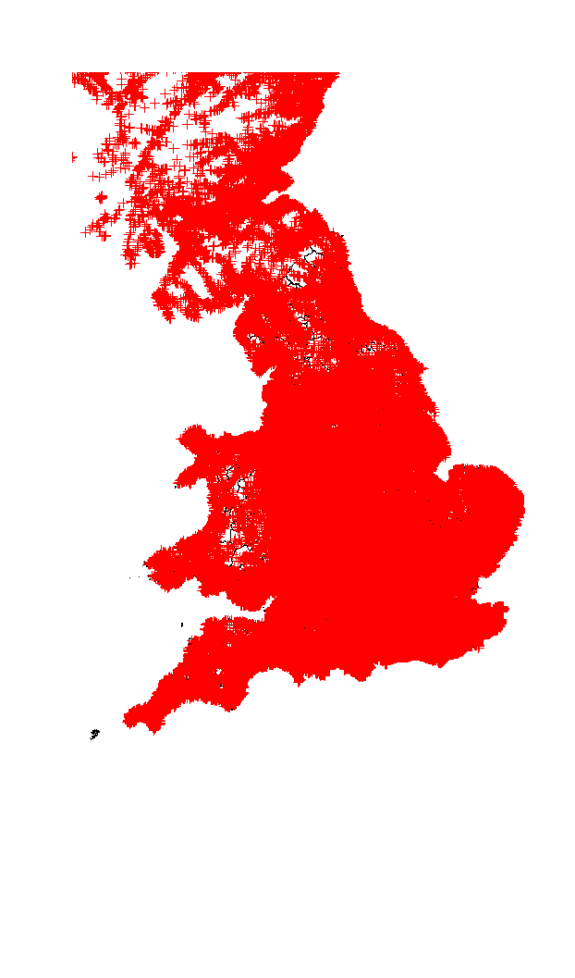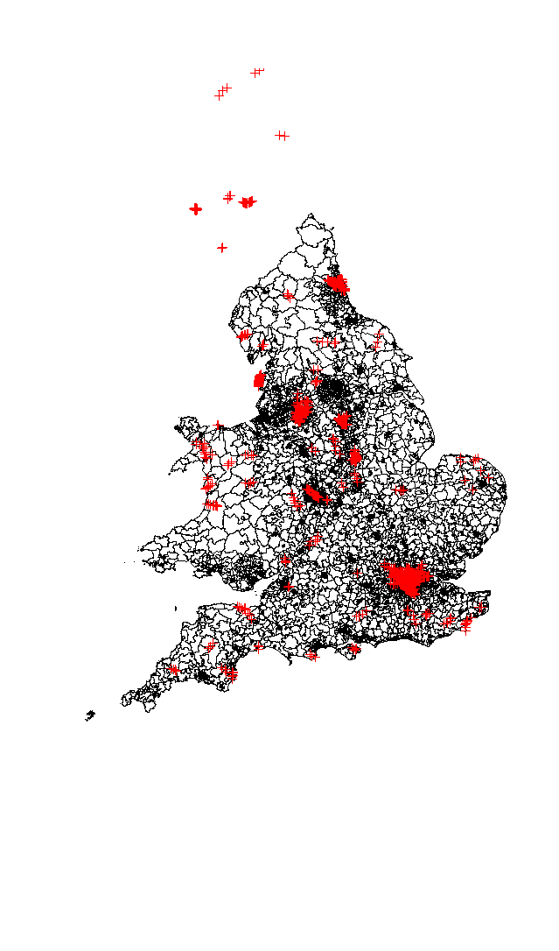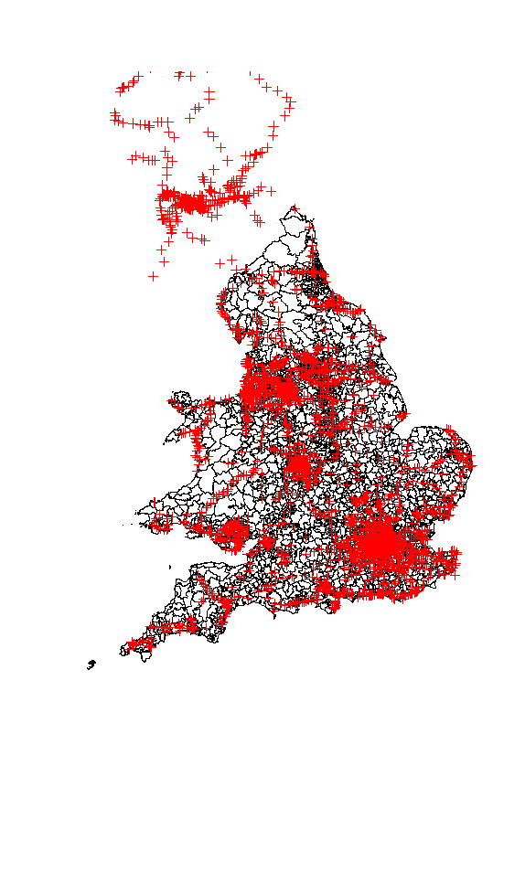

(Further potential story lines could include choropleth maps of accessibility as deemed by unweighted or choropleth maps of travel time by modes)

This shows that there is considerable variation and heterogeneity in transport profile of MSOAs across the UK. Therefore, our aim was to understand whether different groups of MSOAs with a similar transport profile could be identified from within this data. This was done using clustering methods …

The outcome of this was a result of 5 clusters based on the factors of: …

**Cluster analysis:**

These clusters can be described as following (descriptions to be improved for the purpose of the story and report):

Cluster 1: same as 2 but better PT accessibility and train usage **(Rural but central not coastal)**

Cluster 2: Very low PT usage. High dependance on cars **(rural and peripheral - coastal)**

Cluster 3: Very low PT usage. High dependance on cars **(rural and peripheral - coastal)**

Cluster 4: High PT usage and good accessibility **(LONDON and few other big city core msoas)**

Cluster 5: good PT accessibility but high car dependancy **(outer london and other urban areas)**

(it might be worth linking these to 5 different pages showing the same information as the average MSOA information seen above. The data for this could be found in the file cluster_means.csv which gives the means for each variable that went into the cluster algorithm for each cluster value)

**Cluster map and associated information**

(the interactive map showing how the clusters map onto the UK)

**Classification**

(the classification finally to inform demographics)

**Conclusion**